The training programme is promoted by the Stone Cluster, and has been funded and certified by the Ministry of Energy, Tourism and the Digital Agenda through the State Secretariat for Energy

Cosentino Group and the Marble, Stone and Materials Technology Centre work together on a national accident prevention training programme for the stone processing industry

- The programme will cover the entire country this coming May, June and July with more than 30 free training days held in nearly every Spanish province. The goal of this initiative, supported by the Stone Cluster, is to support accident prevention and worker protection from chemical substances in stone and compact quartz cutting and processing workshops across Spain.

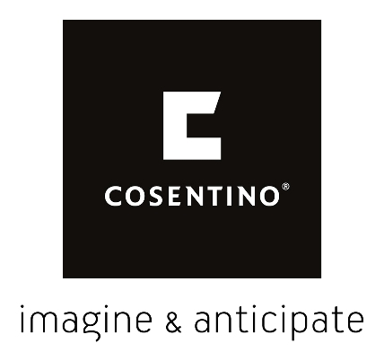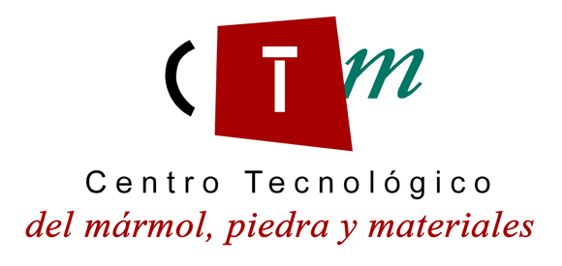

Cantoria (Almeria), 23 April 2018.- Cosentino Group, the Spanish world leader in the production and distribution of innovative surfaces for architecture and design, and the Marble, Stone and Materials Technology Centre (CTM) are set to launch a nation-wide training programme on accident prevention and encouraging safe, healthy working conditions directed at the natural stone and compact quartz transformation and processing sector this coming May. This intensive programme is being promoted by the Stone Cluster, a Spanish industry association of companies involved in natural stone extraction, processing and associated activities. It has been certified by the State Ministry of Energy, Tourism and the Digital Agenda (MINETAD), which is funding the project.

The programme will cover the entire country this coming May, June and July with more than 30 training days, which will be held in nearly every Spanish province. To promote proper accident prevention and worker protection from exposure to chemical substances in stone processing workshops, these training days - which are completely free and include both practical and theoretical material - are directed at owners and workers at stone and compact quartz cutting workshops across all of Spain. Each training session will have a limited number of spots, which will be allocated on a first-come-first-served basis until the maximum capacity (20 people) is reached. Attendees will receive an official diploma for completing the training, certified by the Natural Stone Cluster and the State Secretariat for Energy. The training days will also be supervised by the Provincial Subdelegation or Delegation of the relevant Autonomous Community.

This initiative aims to encourage, in a specialised and holistic way, the training of sector workers in compliance with current legislation. In particular, it focuses on the information that must be provided about exposure to chemical substances and potentially carcinogenic agents specified in current legal regulations on occupational health and safety. The programme will also focus on the proper preventive measures to be taken against exposure to dust and respirable crystalline silica. All of this has the final shared goal of increasing the competitiveness of the sector through best practices and cooperation.

Cosentino Group will play a key role in this programme, as most of the training days will be held at its 18 Centers across Spain. The inaugural sessions will be held at the company’s headquarters in Cantoria, Almeria. In addition, it will provide the methodology from its own ‘Training Classes’ project for stonemasons, which it has used for years both in Spain and internationally. This new Cosentino collaboration is part of its role as a leader in the industry and its permanent commitment to accident prevention and workplace safety, both at its own factories and facilities and externally with clients, partners and suppliers. The Group has also joined other current initiatives; these include, for example, its active collaboration with the PISA Plan promoted by the Government of Andalusia. As one of the pillars of the company’s activities from the very beginning, this commitment to occupational health and safety is also reflected in its steady pace of investment, which allocates a certain percentage of profits every year to developing and leading active policies in this area. In the last five years alone, Cosentino has invested €26.5 million in projects related to occupational health and safety, mainly in measures taken at its production and transformation facilities in Almeria, Brazil and the USA. This figure brings its total investment in health and safety to €100 million over the last two decades.

In a related vein, the Marble, Stone and Materials Technology Centre (CTM) has been working on a number of safety-related interventions; both domestic and international, these aim to improve working conditions by strengthening employability and professionalism, encouraging continuous improvement in areas related to occupational health and safety, competitiveness, well-being and productivity. Its work in this area is supported by a group of researchers, made up of doctors and engineers with various degrees and Master’s qualifications in occupational safety for the proper assessment, notification, training and execution of unique tasks. Its results can be seen in a series of significant figures: in recent years, the CTM has trained over 5,000 people across the country in this area, produced expert reports on workplace accidents, carried out more than three European projects and 30 national projects, participated in more than 20 provincial projects, produced over 100 publications, participated in all kinds of national and international conferences, won a prize for the best occupational safety research team and is currently developing an second version of a patented invention that allows hazards to be identified in real time and big data methods to be used to collect and exploit data. Lastly, the CTM works together with businesses to solve specific issues. Personalised attention, technical rigour and complete satisfaction are the foundation upon which its work is built year after year, making the Centre a leader in the stone sector and related industries. (More information about its latest projects may be found at http://ctmarmol.es/fondodocumental.aspx)

About the Marble, Stone and Materials Technology Centre (CTM)
The CTM is a non-profit Business Research Association that, since its foundation in 1996, has worked to carry out research projects and develop technological services with high added value for the stone sector and related industries, the quarrying sector, the building sector and other related industries. It does so through its various Technology Units: Geology-Mining, Sustainable Building and Architectural Heritage, Industry 4.0, Materials-Nanomaterials, Energy, Water and Environment, Safety, Industry, Training and ICTs.

The goal of the CTM is to create, capture and apply scientific and technological knowledge to contribute to company competitiveness and the progress of society.

CTM’s current lines of research are centred on the development of non-destructive testing techniques, the environment, nanotechnology, industrial safety, industry 4.0 and exploitation of big data analytical techniques, the identification, assessment and mapping of workplace hazards in real time, the sustainable exploitation of natural resources, development of new materials, chemical reformulations, energy efficiency, sustainable building and, lastly, specific training in the framework of which this project forms part. To do so, the CTM carries out projects in collaboration with universities, companies, associations, foundations, public entities and other research centres.
http://ctmarmol.es/

About the Cosentino Group
The Cosentino Group is a global, family-owned company that produces and distributes high value innovative surfaces for architecture and design. As a leading company, Cosentino imagines and anticipates together with its customers and partners design solutions that offer value and inspiration to people’ lives. This goal is made possible by pioneering brands that are leaders in their respective segments such as Silestone®, Dekton® and Sensa by Cosentino®. Technologically advanced surfaces, which allow the creation of unique designs for the home and public spaces.

The group bases its development on international expansion, an innovative research and development program, respect for the environment and sustainability, and its ongoing corporate commitment to society and the local communities where it operates, education, equality and health & safety.

The Cosentino Group currently distributes its products and brands in more than 110 countries, from its headquarters in Almeria (Spain). Currently Cosentino is present in 40 countries, with its own assets in 29 of them. The group has eight factories (seven in Almería (Spain and one in Brazil), one intelligent logistic platform in Spain, and more than 120 commercial and business units throughout the world. More than 90% of Cosentino Group’s financial turnover comes from international markets.

www.cosentino.com

For more information:
Cosentino Group International Communications / Vanessa Feo / vfeo@cosentino.com / +34 616 436 498
www.cosentino.com/blogs-news/news

