Dekton® by Cosentino adds four new colours to the ground-breaking Industrial collection

- Sharing a calm, careful aesthetic, Laos, Soke, Kreta and Lunar are the new industrial colours created in partnership with the Argentinian designer and architect Daniel Germani.
- Cosentino continues to align its innovation and research with global trends and creates new benchmarks at the highest level of aesthetics.

Photos: https://cosentino.box.com/s/hfqwx6wf4mygdw9r5e0yu49f4oxndozv

Cantoria (Almeria), June 2018. Cosentino Group, the Spanish firm that leads the world in the production and distribution of innovative surfaces for architecture and design, has developed four new matte colour offerings to expand the successful Industrial collection of the ultracompact surface Dekton®. In partnership with the Argentinian designer and architect Daniel Germani, Cosentino continues to align its innovation and research with global trends and creates new benchmarks at the highest level of aesthetics.

Laos, Soke, Kreta and Lunar are the new Dekton® Industrial colours, which share a calm, careful aesthetic:

Laos
Inspired by industrial materials, Laos is a transgressive reinterpretation of cement. Dark in colour and with a weathered structure, Laos defines the personality of the Industrial range, reinterpreting it and showing its most innovative side. Its aesthetic is based on a matte finish with grey veining and golden tones, ideal for the most avant-garde settings.

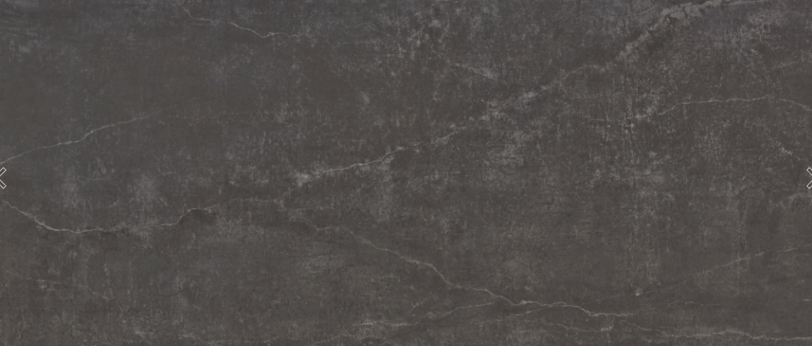

Soke
With a careful, distinguished look, Soke is a colour inspired by classic cement flooring. Its structure of realistic cracks is subtly integrated into a background full of detail. Grain and base blend to perfection in a range of greys, becoming a versatile colour for any application.

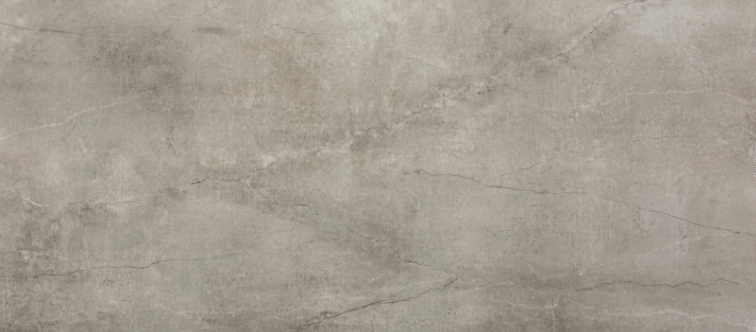

Kreta
Inspired by classic cement flooring, Kreta appears with a calm structure. Its design is uniform and restrained, though areas of dark and light appear at random depending on the density of the grain. Its matte texture and grey colour are an ideal match for any kind of material.

Lunar
Inspired by industrial aesthetics, Lunar is a reinterpretation of conventional cement. Its smooth structure and white base make the colour Lunar a fashion item. Its pattern and background come together in a balanced, harmonious way, offering a sublime result for modern décor.

With the launch of Laos, Soke, Kreta and Lunar, the Dekton® Industrial collection colour range now includes eight innovative colour offerings. Dekton® Industrial began in 2017 with the colours Trilium, Radium, Nilium and Orix, becoming the most casual, ground-breaking Dekton® collection thanks to its urban style.

Dekton® Industrial calls up the metal, rust and cement tones that were the trends of yesteryear, making them into the best allies of designers and architects across the world. Its striking aesthetic makes it a guaranteed success for applications in both interior and exterior spaces, as it comes with the outstanding technical properties characteristic of Dekton®: UV, scratch, stain and heat resistance, production in large-format slabs (up to 144 cm x 320 cm) and different thicknesses (30mm, 20 mm, 12 mm and 8 mm).

About Dekton® by Cosentino

Dekton® by Cosentino is a revolutionary and innovative the ultracompact surface for the world of architecture and design. It is a sophisticated mixture of the raw materials used to make glass, next-generation porcelain surfaces and quartz surfaces. It is made with exclusive Sinterized Particle Technology (TSP), which is an innovative ultra-compaction process.
It boasts superior technical properties, such as resistance to UV rays, scratches, stains and thermal shock, and very low water absorption. Dekton® is able to recreate any type of material with a high level of quality. It is manufactured in large-format slabs (up to 320 cm x 144 cm) in five different thicknesses (0.4cm, 0.8 cm, 1.2 cm, 2 cm and 3 cm). Dekton® is the perfect surface for a wide range of applications, both indoors and outdoors (façades, paving, cladding, worktops, sinks, etc.).
As part of our commitment to sustainability and a circular economic model, various Dekton® colours are made with recycled materials from the product’s own manufacturing process. In 2016, Cosentino obtained an Environmental Product Declaration for Dekton®.
Dekton® has been chosen to feature diverse architectonic and design projects throughout the world, like Rafa Nadal Academy by Movistar in Manacor, the residential building Valdebebas 127 in Madrid, the 4* and 5* Hipotels hotels in Palma de Mallorca, the Gunni&Trentino showroom in Madrid, TOPA Sukalderia in San Sebastian, Archway Tower in London, Le Meridian hotel in Yilan (Taiwan), Cap Ferrat building in Rio de Janeiro or the restaurant The French Laundry of chef Thomas Keller in California. www.dekton.com

More information:
Vanessa Feo – Cosentino Group International Communications – vfeo@cosentino.com – 616 436 498
https://www.cosentino.com/news/

