Silestone Institute recommends

Cook healthier dishes taking advantage
of seasonal foods
Did you know that seasonal foods are healthier, cheaper and more organic?

Although this spring we have to be in confinement, we want to take the opportunity to remember what seasonal foods we have within our reach and that will allow us to save on purchases and at the same time, enjoy cooking by preparing fresher, richer and healthier meals.

Fruits and vegetables in April continue in abundance. When summer arrives, its variety will decrease, so it is time to make the most of it.

Food that we can enjoy in spring

An orange juice, in the morning, can continue to be part of the menu. Since it continues to be a seasonal fruit in addition to other citrus fruits such as grapefruit or lemon.
The fruit that predominates the most this season is strawberries, a very healthy food that is at its best.

Among the vegetables, we can still enjoy cabbages, chicory, spinach, chard and celery. And, if you like artichokes, make the most of them because you have little time left in the optimal season.

On the other hand, salads begin to appeal, which can be with ingredients such as avocado, apple, spinach, young garlic, young onions, asparagus or carrots. All fresh and own ingredients from the garden.

The outstanding vegetable of the month of April is the green bean that is added to other vegetables that continue in season such as peas, young beans and mangetouts.

Another food that proliferates in spring thanks to humidity and mild temperatures is mushrooms, a rich and healthy food that you can add to both your salads and stir-fries.

As for fish, cod is in season and others are added to this, such as
the swordfish, which is very delicious to cook on the grill, and also the anchovies that prepared in vinegar are very rich and healthy.

Furthermore, although we can find the skewer hake throughout the year, it is in the spring, until well into the summer, when we take full advantage of the properties of its meat.

Summary of seasonal food for April.

• Fruits: Strawberries, kiwis, lemon, lime, orange, banana, passion fruit, apricots, loquat, papaya, pineapple, grapefruit, avocado, apple and persimmons.

• Vegetables: snow peas, young beans, peas, spinach, leeks, zucchini, broccoli, garlic, asparagus, beets, cucumbers, radishes, leeks, carrots, celery, artichokes, cabbage, lettuce, squash, eggplant, green beans and endives.

• Fish: Eels, eel, cod, sea bream, mackerel, carp, lamprey, liba, sea bass, grouper, palometa, perch, salmon, shark and trout.

• Seafood: Cockles, clams, razor clams, scampi, prawns, prawns, mussels, oysters, cuttlefish, choco, shrimp, octopus, barnacles and scallops.

• Meats: Woodcock, beef, quail, maids, pheasant, chicken, liver, wild boar, hare, gizzards, cow, deer, suckling pig, rabbit, lamb, pheasant, chicken, pork, duck, turkey, partridge, chicken and veal.

The kitchen is a space where we spend much of our time, and even more now in these moments of confinement. So let's take the opportunity to spend less and eat healthier by cooking dishes with fresh, seasonal food.

#IStayinthekitchen

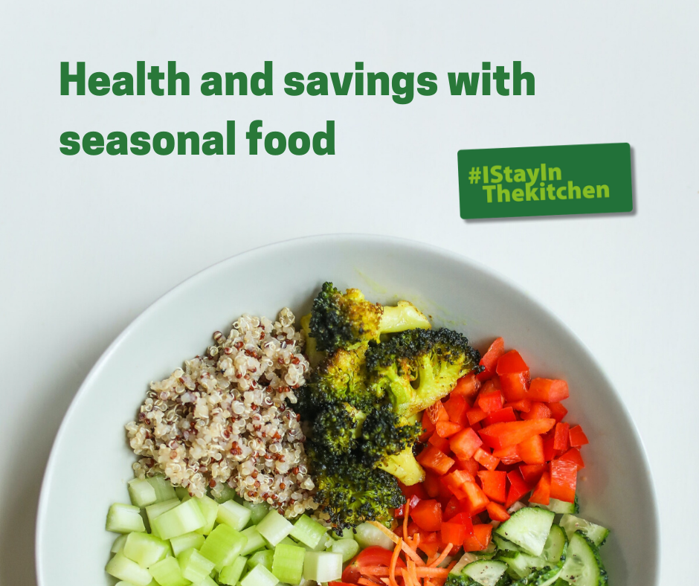

Silestone Institute: is an international platform dedicated to researching and disseminating knowledge about the kitchen space, both domestically and professionally. The Institute is an initiative promoted by the Cosentino Group, a world leader in the production and distribution of cutting-edge innovative surfaces for architecture and design.
www.silestoneinstitute.com
http://silestoneinstitute-10years.com/

