Global Kitchen study “The kitchen, the heart of the home”

The kitchen: an ecosystem to improve our health and wellbeing

- The kitchen space must be designed to help us improve our eating and cooking habits as well as taking care of our health
- We must consider how we can adapt our kitchen to current health and wellness needs.

Barcelona, ​​May 12, 2020.- Within the present global health crisis we are experiencing, taking care of our health is now more important than ever. We must be aware of the care of our mind and body, incorporating healthy habits when buying and cooking food as well as adapting spaces for this purpose.
The kitchen is increasingly an ecosystem devoted to take care of health and wellbeing. Living in a healthy way -understood as being comfortable and feeling good, both physically and mentally- depends as much on our own habits and behaviors as well as on the environment in which we live.
Before the present health crisis, the Global Kitchen study survey addressed to the final consumer and kitchen and bathroom showrooms conducted in 9 countries (Spain, Italy, the United Kingdom, Scandinavia, the United States, Canada, Australia, Singapore and the United Arab Emirates) already pointed out some evidences about how habits towards a healthier way of life were changing.
Change of habits for health and wellness care

- 49% have changed eating habits in the last years
- 41% consume less processed food
- 31% cook properly and try not to eat processed foods
- 22% take care of the origin of the food

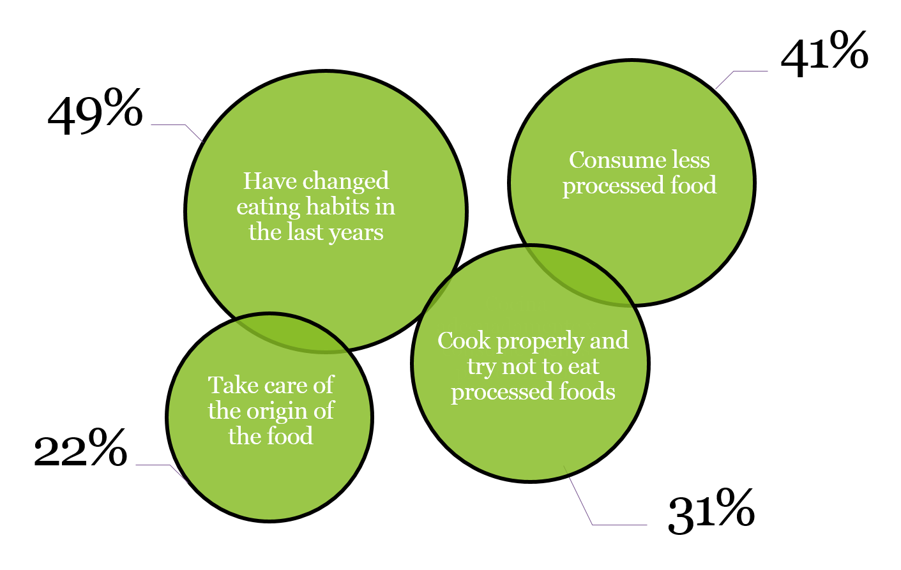

According to the study, the interest in following a healthy life has modified some of the traditional eating patterns, either for nutritional reasons oro due to growing concern about the quality and origin of food. This has Broughten about changes in the purchase, storage and preparation of food and with it the introduction of new ways of planning and organizing kitchens.

#IStayinthekitchen

Expert opinion
“Chefs influence changes in eating habits, both in the choice of food (from different cultures or organic) as well as the cooking processes followed, and the types of utensils used.”
Paco Roncero. Chef

Especialista en psiconeuroinmunología

“Famous chefs have the responsibility to promote and spread messages that educate and raise awareness in society, both in the field of responsible consumption and the basic techniques and habits for healthy eating, as well as in regard to being environmentally friendly. Ángel León. Chef

“Interest in the origin of foods also influences the way we cook them”. Amy Bentley. Historiadora experta en alimentación.

The Global Kitchen study, presented in 2019, is based on a consumer survey in 9 countries (Spain, Italy, the United Kingdom, Scandinavia, the United States, Canada, Australia, Singapore and the United Arab Emirates) and on the expert vision of 23 professionals from different specialties.
In the 21st century, we need to reflect further on this matter so that the kitchen continues to be part of our culture and our daily habits, with the goal of improving health at every step of the food chain.
Global Kitchen study

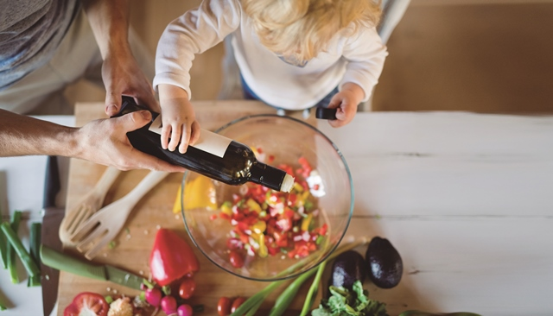

Silestone Institute: is an international platform dedicated to researching and disseminating knowledge about the kitchen space, both domestically and professionally. The Institute is an initiative promoted by the Cosentino Group, a world leader in the production and distribution of cutting-edge innovative surfaces for architecture and design.
www.silestoneinstitute.com
http://silestoneinstitute-10years.com/

