Cosentino marks presence at INDEX with “RELounge” created in collaboration with American University of Sharjah

Sustainably produced installation will host interviews and behind-the-scenes highlights
of INDEX, the Middle East largest gathering for the design community

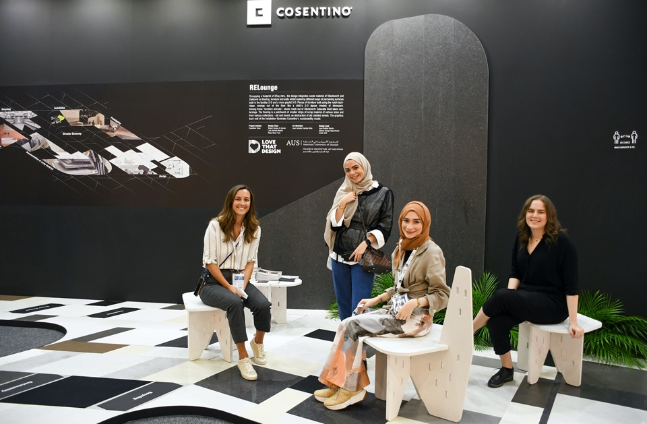
Dubai, 1 June 2021 – Global architectural surfaces leader Cosentino unveiled “RELounge” at INDEX– a sustainably produced installation created in collaboration with the American University of Sharjah (AUS). Built almost entirely out of scraps of Cosentino’s hero surfaces Dekton® and Silestone®, collected from the brand’s fabricators in the UAE, the installation is symbolic of Cosentino’s commitment to sustainability and a circular economic model.
Occupying a footprint of 32sq mtrs, the design integrates waste material as flooring, furniture and walls whilst exploring different ways of perceiving surfaces both in the familiar 2-D and a more playful 3-D. Pieces of furniture built using the notch technique, a playfully strewn across the floor like a child’s 3-D jigsaw models of dinosaurs. The flooring is a patchwork of smaller strips of scrap material of various sizes and from various collections - old and recent, an abstraction of old cobbled streets. The graphics back wall of the installation, illustrates Cosentino’s sustainability model.
Commenting on the engagement with AUS, Miriam Llano, Marketing Manager – Cosentino Middle East said, “Back in 2018, we successfully collaborated with AUS to create an installation at Downtown Design. In this second edition of our partnership, we really wanted to focus on our values of sustainability. Today Cosentino’s production process is an environmental success story, carried out using 99% recycled water, 100% renewable electric energy and reused raw materials. This ethos percolates into the design of RELounge. It is a relaxed lounge environment that is the product of reconstituting, recycling and reimagining materials.”

Reflecting on the experience, Juan Roldan, Associate Professor of the Interior Design Department at CAAD, AUS said, “The design concept evolved out of the many restrictions we had while working with scrap materials. We have intentionally tried to stay away from the idea of upcycling which we feel is a dead-end process. Our focus has not only been to reconstitute the scraps to give it a functional and aesthetic second life, but push the circular economic scheme further by considering a potential third life after it is dismantled. Working on RELounge has been a great experience for our students to get a taste of professional life with real deadlines and budgets.”

The installation also hosts a media lounge by Love That Design, a working studio that will capture all the ‘Behind the Scenes’ action at INDEX. Specialists in creating design-focused digital content, Love That Design will be hosting many a tete-a-tete with designers, manufacturers and prominent personalities from the regional A&D industry.
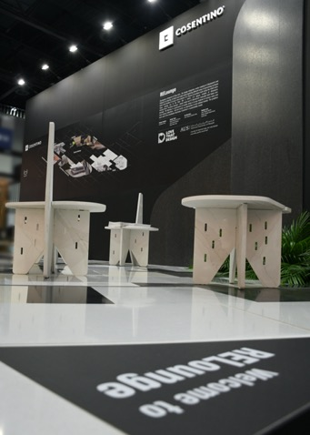
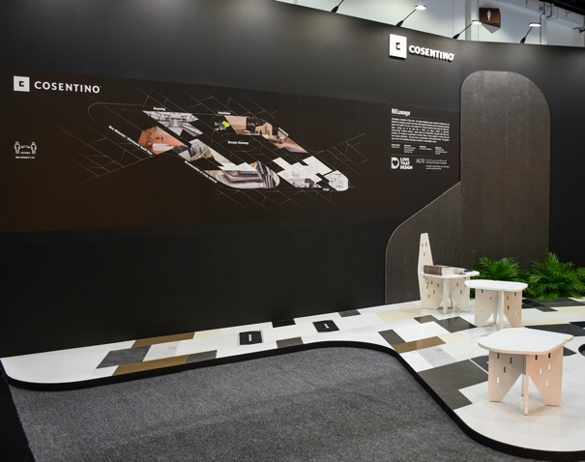

About the Cosentino Group
Cosentino Group is a global, family-owned company that produces and distributes high value innovative surfaces for architecture and design. As a leading company, Cosentino imagines and anticipates together with its customers and partners design solutions that offer value and inspiration to people’s lives. This goal is made possible by pioneering brands that are leaders in their respective segments such as Silestone® and Dekton® by Cosentino®. Technologically advanced surfaces, which allow the creation of unique designs for the home and public spaces.
The group bases its development on international expansion, an innovative research and development program, respect for the environment and sustainability, and its ongoing corporate commitment to society and the local communities where it operates, education, equality and health & safety.
Cosentino Group currently distributes its products and brands in more than 110 countries, from its headquarters in Almeria (Spain), and it’s present with its own assets in 30 of them. The group has 8 factories (7 in Almería, Spain and 1 in Brazil), 1 intelligent logistic platform in Spain, and 140 commercial and business units throughout the world. More than 90% of Cosentino Group’s financial turnover comes from international markets.
www.cosentino.com

