Ethereal by Silestone®, Beauty Beyond Natural

- Silestone® by Cosentino launches its second series under the new corporate image recently presented by the brand. It also comes with a major campaign named “The Metamorphosis” featuring entrepreneur and international fashion icon, Cindy Crawford.
- Ethereal Dusk, Ethereal Haze, Ethereal Glow and Ethereal Noctis are the names of the four new colours of this marble-inspired series which recreate the dream-like beauty of the sky.
- Silestone® Ethereal presents the new and exclusive HybriQ+® technology, a milestone in the industry which entails a new production process and composition for Silestone®, where the presence of crystalline silica is significantly reduced while achieving great sustainability levels both in the composition of the product and in the manufacturing process.

Cantoria (Almería), October 2021.- Silestone® by Cosentino, the world’s leading hybrid mineral surface for architecture and design, is launching its second series worldwide under its new corporate image. The new Silestone® emblem and character has given rise to the Ethereal collection, which also comes with a major campaign featuring entrepreneur and international fashion icon, Cindy Crawford.

Ethereal by Silestone® represents a quantum leap in terms of design, innovation and sustainability, in line with the transition that the Silestone® brand name is undergoing externally and internally with the development of the cutting-edge HybriQ® technology. This evolution of Silestone® leads to a series of patterns over a white canvas designed to become a best-seller in interior design, and which are the main reason for the title of Cindy Crawford’s campaign with Silestone® Ethereal, ‘Metamorphosis’.

Link to campaign with Cindy Crawford
Download Silestone® Ethereal Images

This marble-inspired collection consists of four colours, namely Ethereal Dusk, Ethereal Haze, Ethereal Glow, and Ethereal Noctis, which recreate the dream-like beauty of the sky. The designs offer a deep, fine veining on a white foundation.

Silestone® Ethereal

Ethereal Dusk showcases an urban look in which the bluish tone of its veining brings a modern and avant-garde touch to the space. It symbolises a unique, unforgettable and personal sunrise, in which peace, solemnity and tranquillity are seen on the horizon in the last moments of darkness.

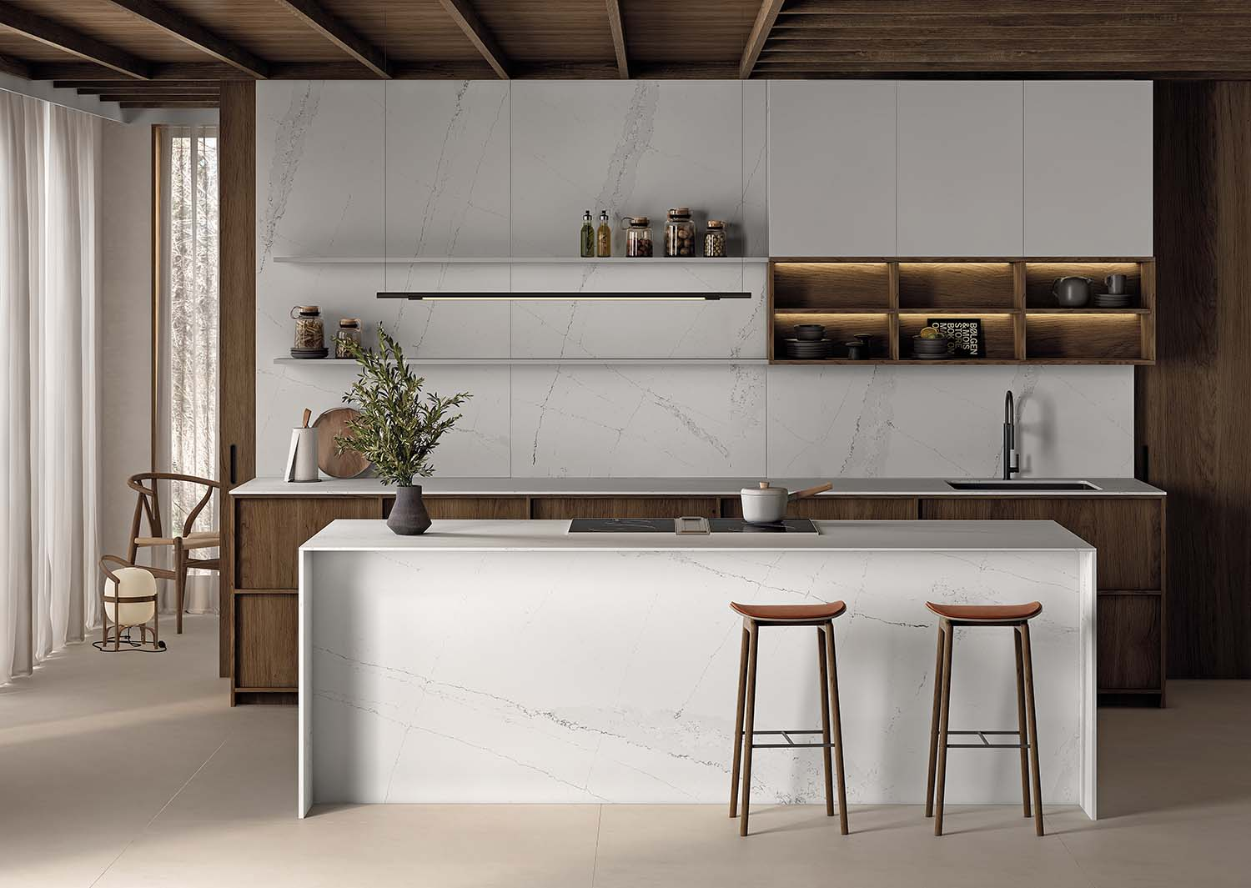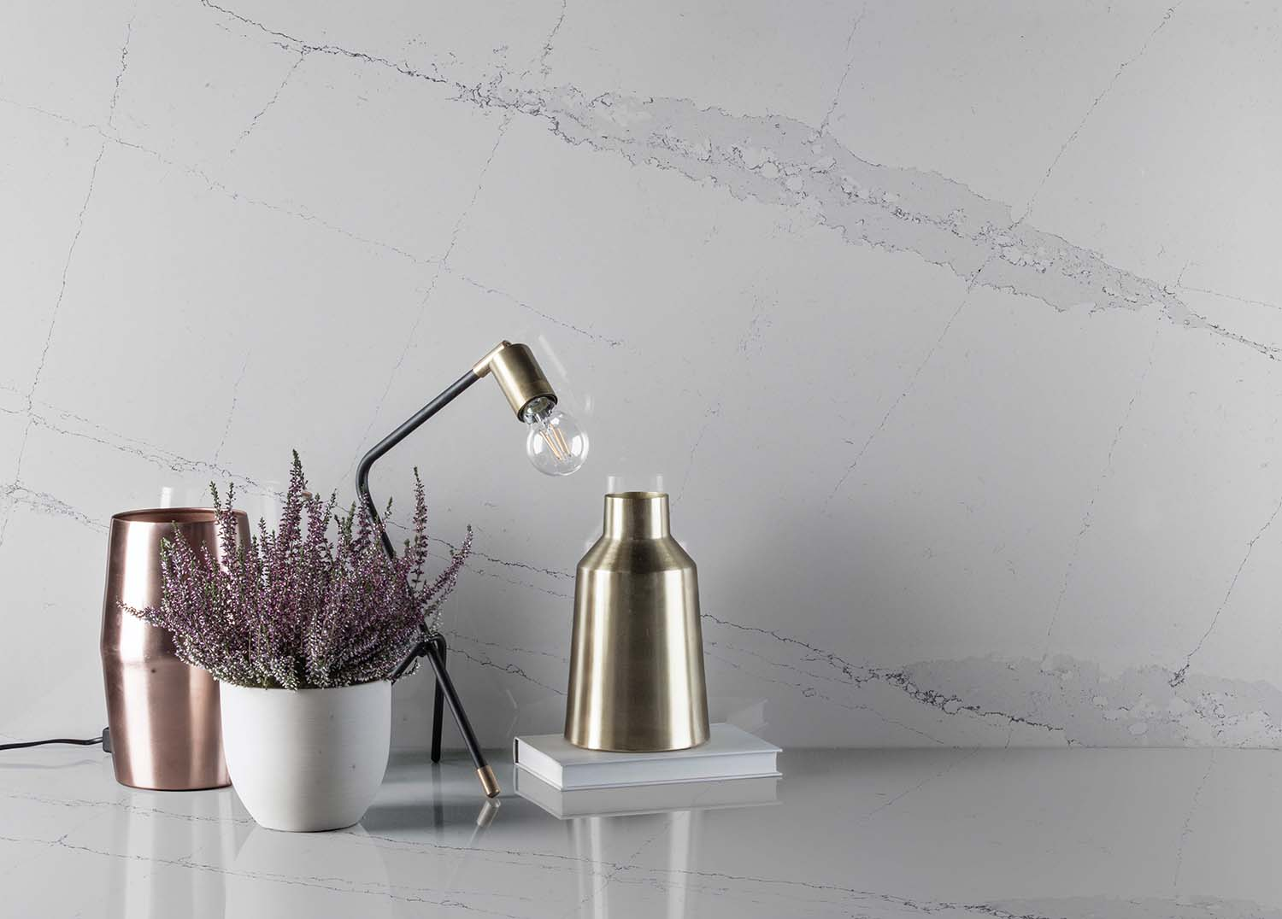

Ethereal Haze includes a dynamic range of grey tones to emit plenty of personality. This colour conveys both calm and character thanks to an interplay of gradients which blend into pure neutrality. Ethereal Haze takes us to an imaginary world where the wind moves the clouds over the mountains, creating an optical illusion of tranquillity and fluffiness.

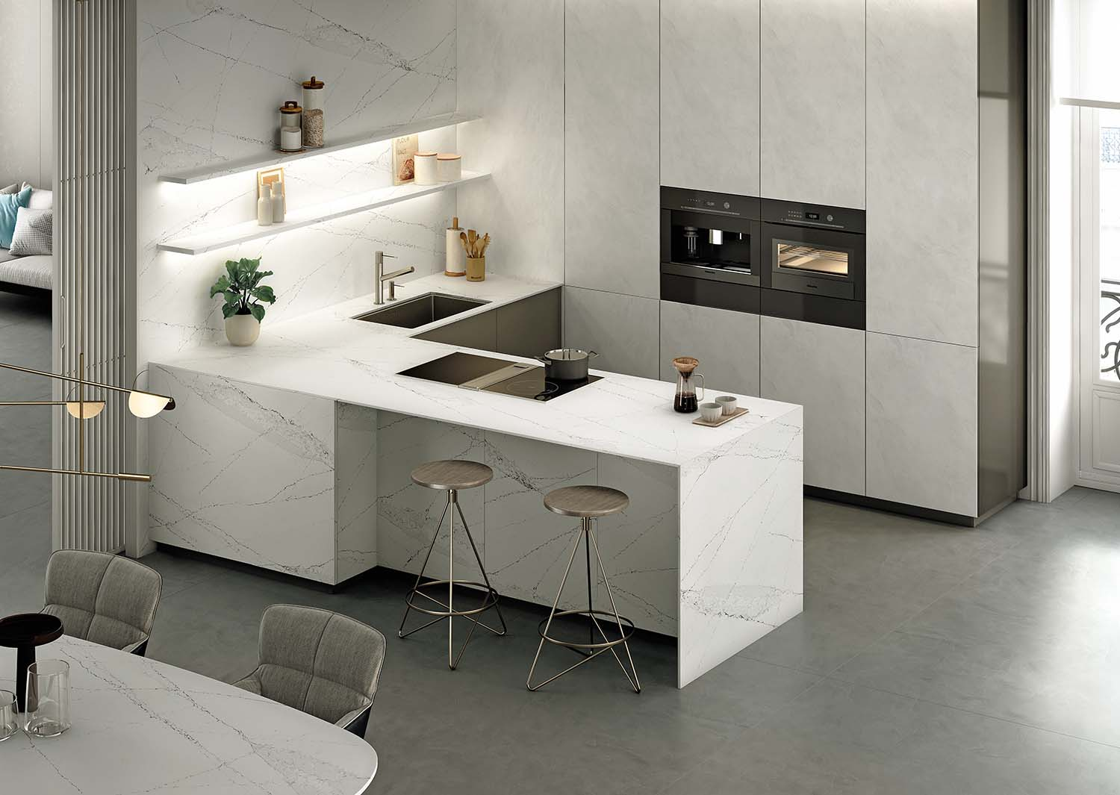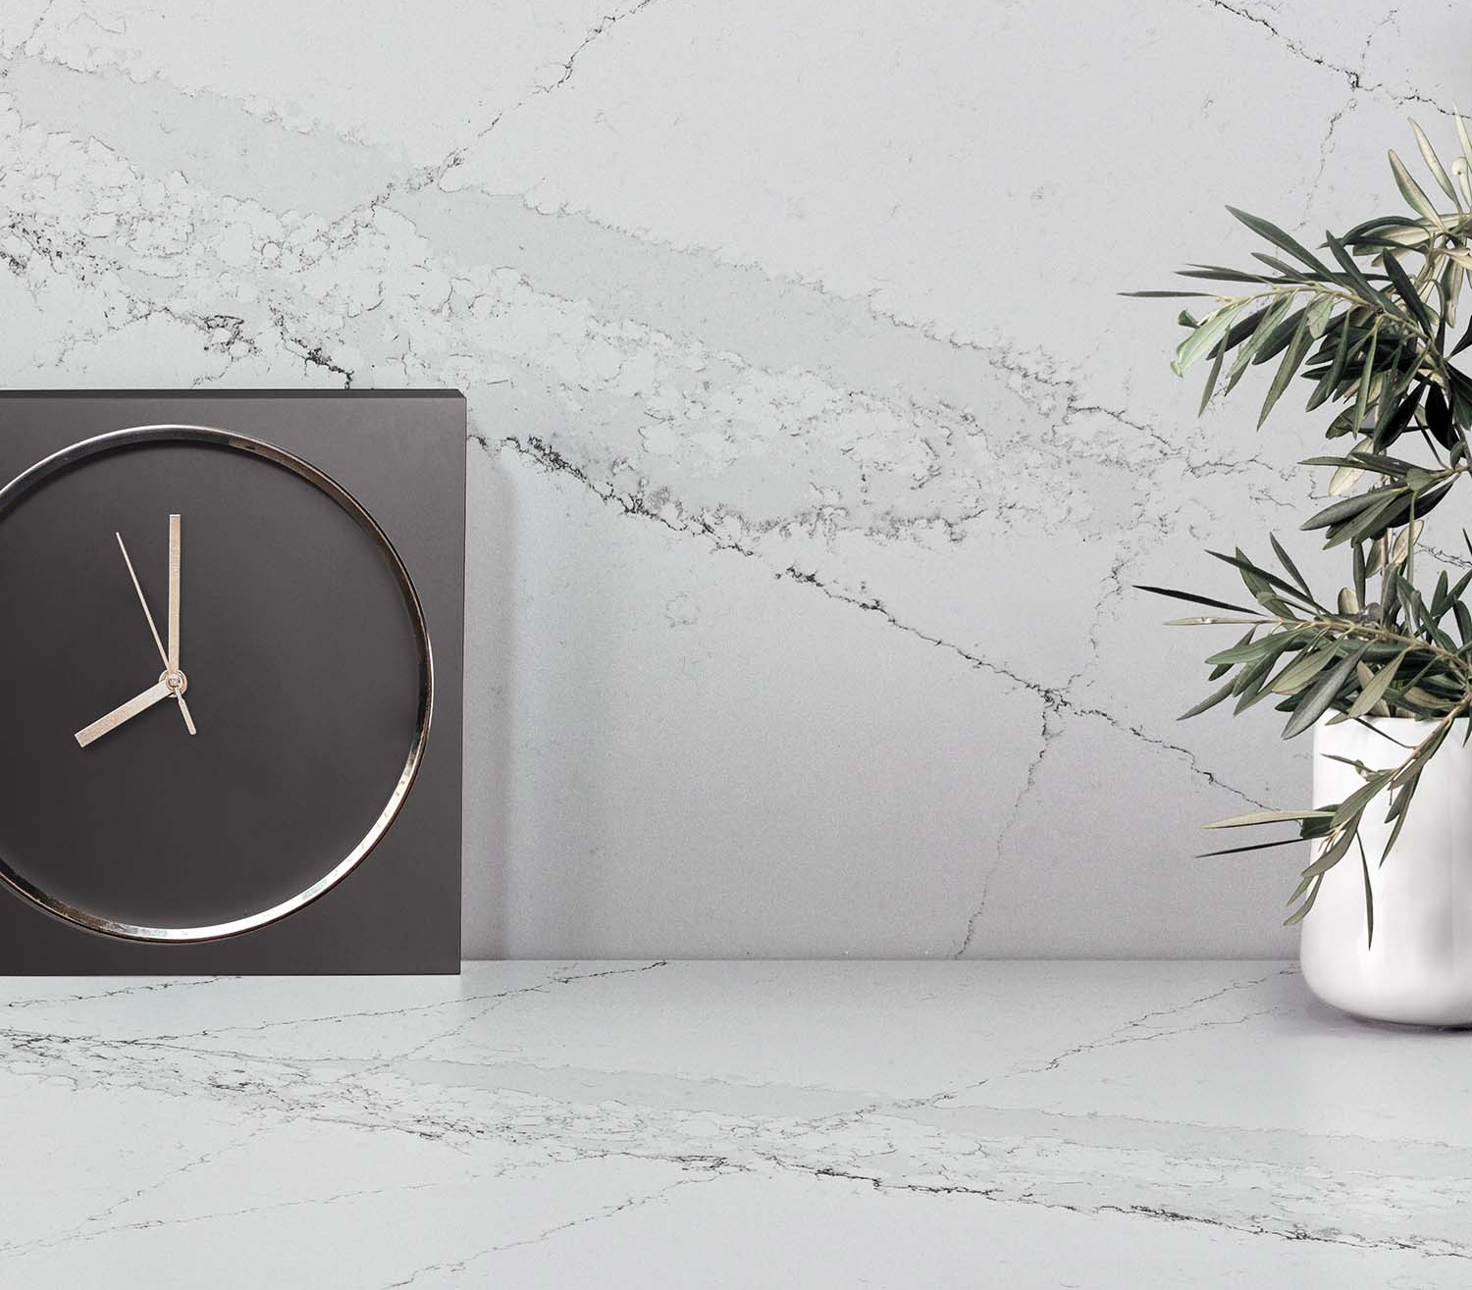

Ethereal Glow is simply pure, classic elegance. Its golden and grey veining merges with a tinged white foundation, running through the entire design and bringing an accent of colour to every corner. It is inspired by the sunset and its igneous colours and glow, a vision from which you cannot look away. It is an evolution of our internationally acclaimed Silestone® Eternal Calacatta Gold colour.

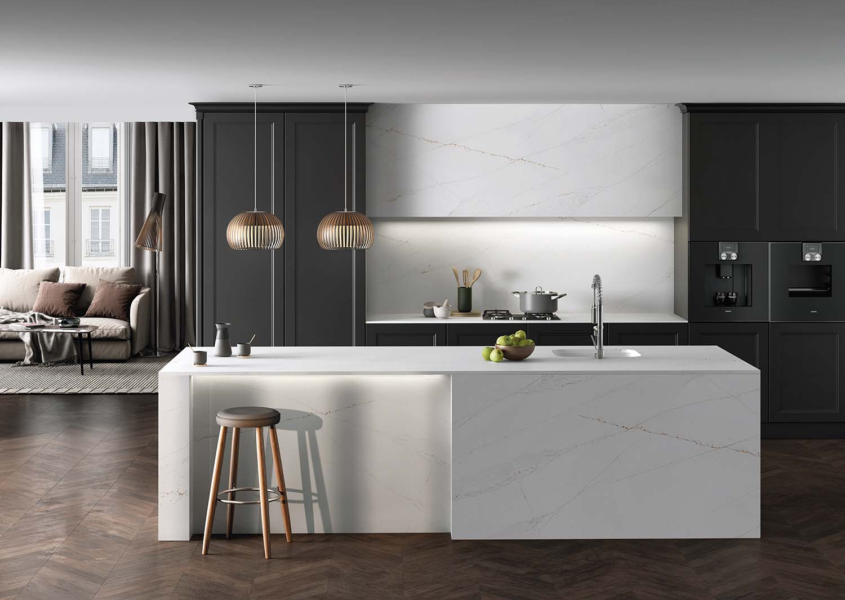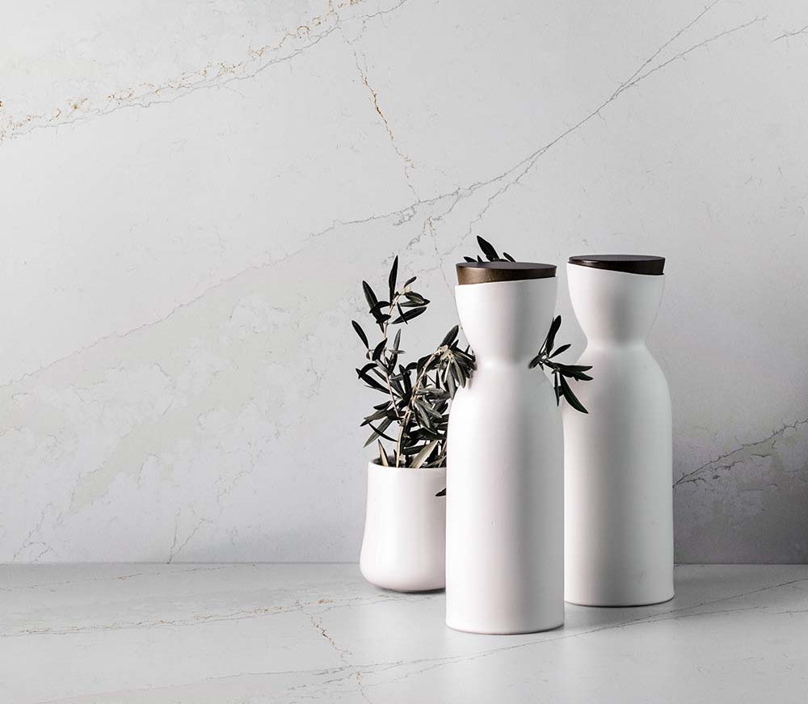

Ethereal Noctis is synonymous with sophistication. The tinged white foundation is broken up with short grey and black veins, providing contrast, depth, simplicity and modernity. It is inspired by the darkness after sunset, making us feel life with a strange halo of unreality.

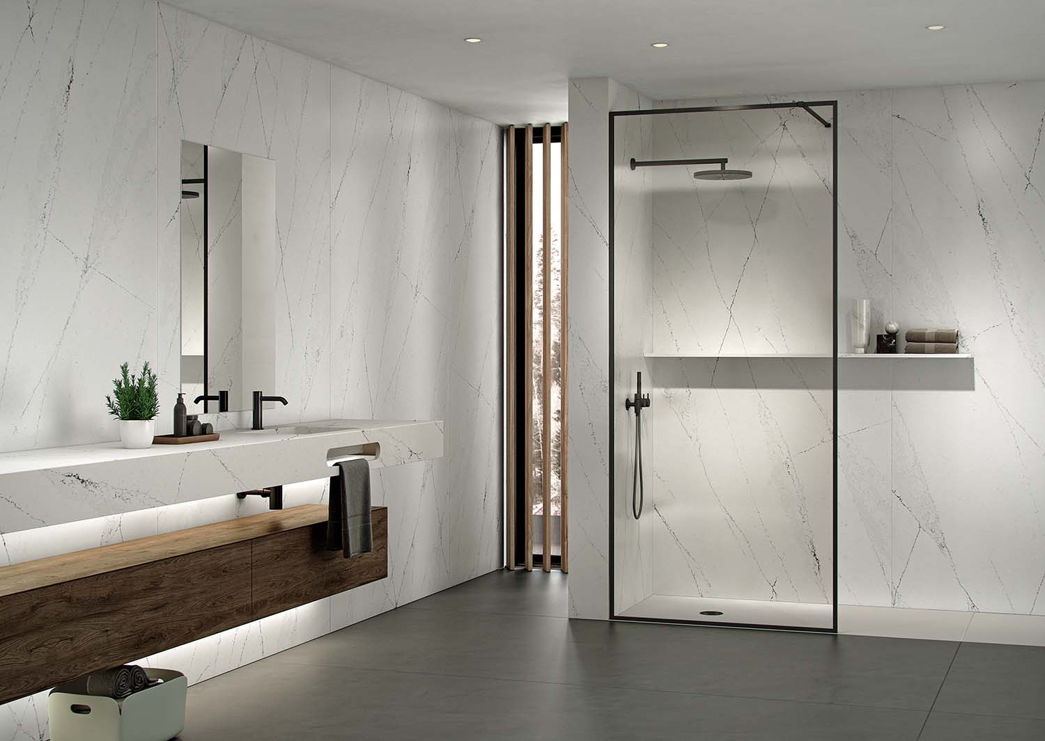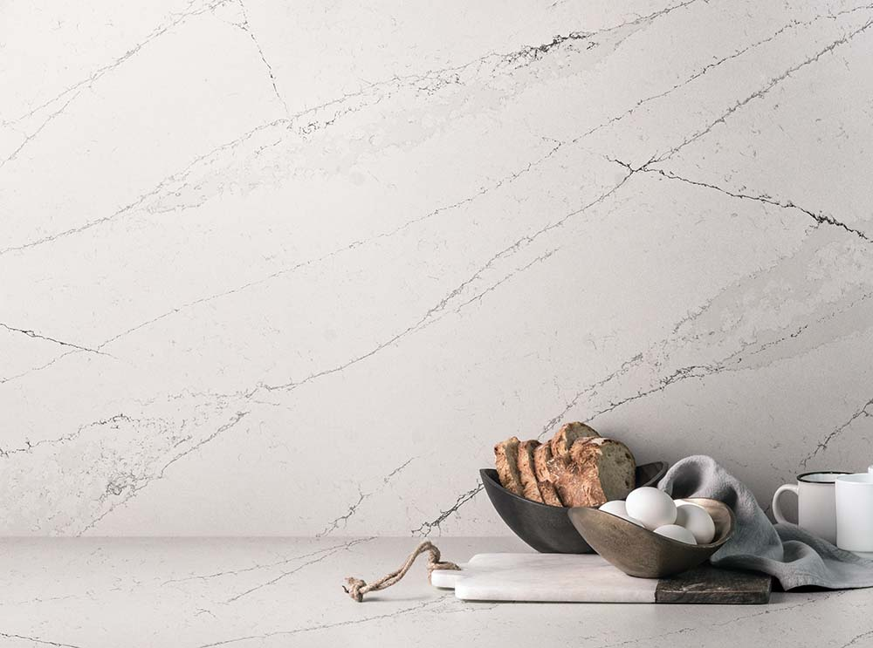

Silestone® Ethereal & HybriQ+®

Silestone® Ethereal is the result of HybriQ+®, the exclusive and pioneering technology developed for Silestone® by Cosentino. HybriQ+®, launched in 2020, is a qualitative leap in the evolution of Silestone® brand. It is a new production process characterised by the company’s commitment to the environment, the circular economy and sustainable management. With HybriQ+®, in addition to Cosentino’s environmental milestones, such as the use of 99% recycled water and 100% renewable electric energy in the production process, at least 20% of recycled raw materials are used in the manufacture of Silestone®.

Furthermore, HybriQ+® technology stands out for its new formulation in the composition of Silestone®, where the presence of crystalline silica is significantly reduced. Instead, a new hybrid formulation of mineral raw materials with equal or better performance than quartz and materials of a recycled origin is used. With this new composition, Silestone® benefits from the same mechanical and technical features and an appearance that enhance its beauty, but with a sustainable focus and new design possibilities including improved depth and translucency.

